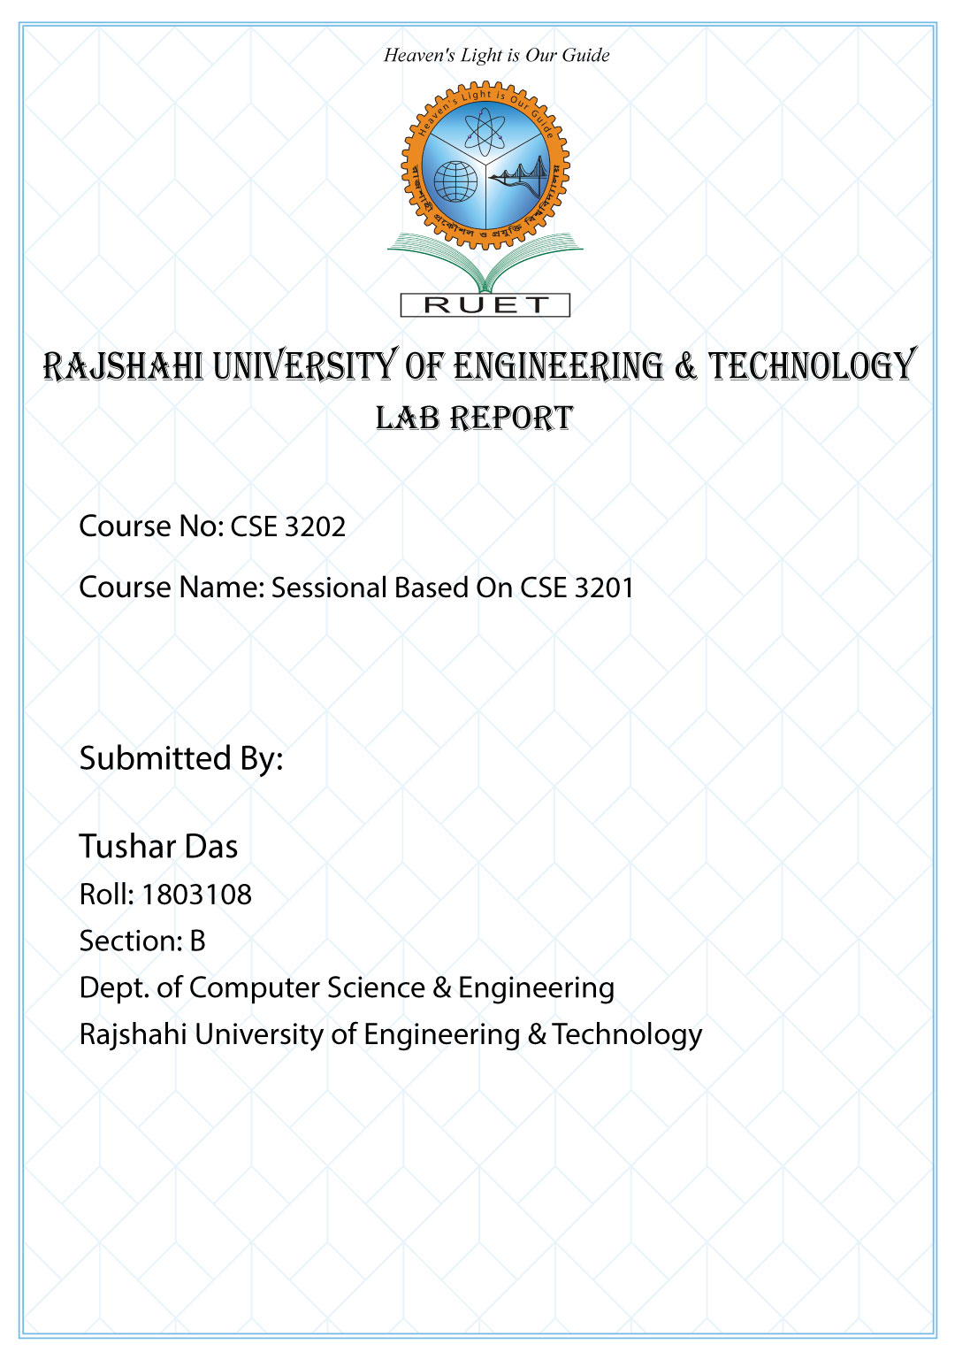**Lab 01**

**History of Linux**

* Linux is a community of open-source operating systems that are developed on top of the Linux kernel. Linux comes packaged within Linux distributions.
* Linux distributions, or fondly called distro, are nothing but software collections based on the Linux kernel and a package management system.
* First developed as a small but self-contained kernel in 1991 by Linus Torvalds, with the major design goal of UNIX compatibility.
* Its history has been one of collaboration by many users from all around the world, corresponding almost exclusively over the Internet.
* It has been designed to run efficiently and reliably on common PC hardware, but also runs on a variety of other platforms.
* The core Linux operating system kernel is entirely original, but it can run much existing free UNIX software, resulting in an entire UNIX-compatible operating system free from proprietary code.
* Version 0.01 (May 1991) had no networking, ran only on 80386-compatible Intel processors and on PC hardware, had extremely limited device-drive support, and supported only the Minix file system.

**What is Shell?**

* A shell is special user program which provide an interface to user to use operating system services.
* Shell accepts human readable commands from user and convert them into something which kernel can understand.
* It is a command language interpreter that execute commands read from input devices such as keyboards or from files. The shell gets started when the user logs in or start the terminal.

**Linux Commands**

**cd :** For changing directory

**cd /mnt/e:** change the directory to E disk on the hard drive

**cd STUDY/3_2/OS/Labs/1**

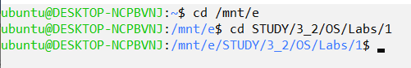

**pwd:** where the director is



**touch:** Create new file



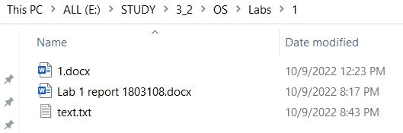

**ls -al:** Show all files

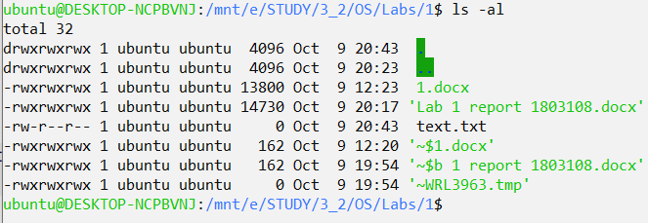

**nano:** Write in the file



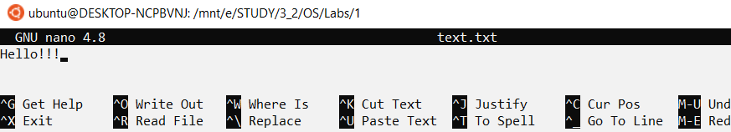

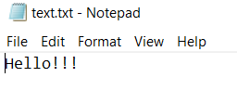

**cat:** Read from file



**rm:** Delete file



**mkdir:** Make a folder

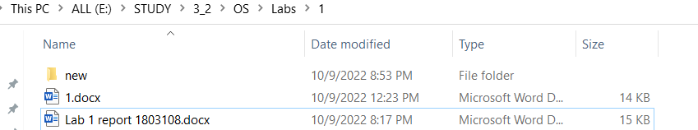

**rm -R:** Delete folder



**cd .. :** go to previous directory



**chmod:** change permission



